XTEND 4.0
REPEATER 136-174MHz
Ready-to-use, high gain, digital filter (option) & rugged repeater Multi modulations operation with TruPWR™ (TETRA/INPT/DMR/ANALOG) Cost-effective remote unit (+17/+30dBm)
RFFO (optical fiber) or RFRF operation

Key features


Ultra-fast 100µs squelch / timeslot ALC based to avoid near BS desensitisation And to allow a large number of MS connections along the RU


 In-house WDM RFoG system up to 16 RUs and distance of 35km  Remote unit with low and high-power cost-effective solution  Secured Talk2M© monitoring cloud from EWON© (option)
Low time equipment deployment thanks to plug & play system

 Full compatible with MDAS© product range

Benefits

 Reliability and easy maintenance with no RU with FAN  Low monitoring development cost with the Talk2M©
 Unconditionally stable and usable with existing optical fiber  Monitoring over optical fiber

OPTICAL FIBER DAS & RFRF REPEATER

Poor or inexistent PMR coverage is a problem for public safety infrastructure (building, tunnel…).
We are providing a full range of 136-174 MHz indoor repeater, for all kind of application.

  - OPTICAL FIBER DAS (DISTRIBUTED ANTENNAS SYSTEM)

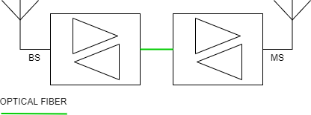
Figure 1 RFFO REPEATER
Our DAS is using an in-house master unit (MU), with the following advantages:
    - Network safe with no noise guaranteed
    - Uplink dynamic ALC & ultra-fast 100µs squelch (uplink muting with no MS)
    - Digital filter (option)
    - In-house monitoring for critical network with MOR (minimum operating requirements)
    - Plug & play and ultra-secured monitoring platform with Talk2M©

Our DAS is using an in-house analog optical master unit (OMU), with the following advantages:
    - Single mode optical fiber
    - Long distance up to 35KM achievable
    - Up to 16 remote unit with only 6x 1U OMU

Our DAS is using an in-house remote unit (RU), with the following advantages:
    - Cost effective solution
    - In-house monitoring for critical network with MOR (minimum operating requirements)
    - Optional leaky feeder monitoring, bias voltage for in-line BDA and custom request
    - Local I/O (option)

  - RFRF REPEATER

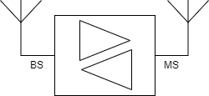
Figure 2 RFRF REPEATER
Our RFRF repeater provides ready-to-use, high gain, digital filter (option) and high power (option) in a compact box:
    - Plug & play with automatic RF setup
    - Network safe with no noise guaranteed
    - Up to 90dB of gain
    - Uplink dynamic ALC & ultra-fast 100µs squelch (uplink muting with no MS)
    - Digital filter (option)
    - Monitoring for critical network with MOR (minimum operating requirements)

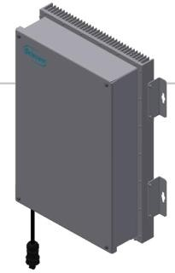

Monitoring architecture

With the secured Ewon© Talk2M© monitoring platform and a unique ID hardware, turn on your equipment and get a full monitoring solution in few minutes, with your dedicated Talk2M© account user.

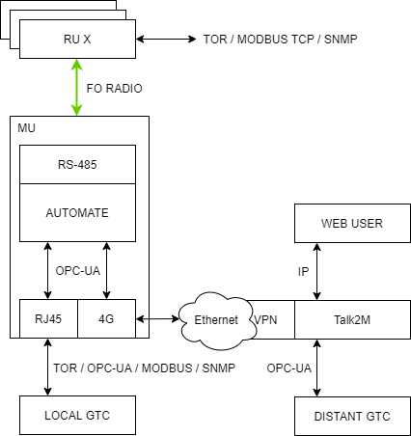

Specifications

RF features
Frequency bands | UL (MHz) | DL (MHz)
 | 136-174 | 136-174
Spacing duplex | 4.45-13MHz
Bandwidth (*option: digital filter) | 1.2MHz (12.5 KHz to 1.2 MHz*)
UL POWER | +17dBm
DL POWER (*option: linearized PA) | +17dBm | +30dBm*
OIP3 | +48.5dBm | +56dBm
Rated output power per channel (DL)
1 channel | +17dBm | +30dBm
2 channels (60dBc) | +14dBm | +27dBm
4 channels (60dBc) | +11dBm | +24dBm
8 channels (60dBc) | +8dBm | +21dBm
16 channels (60dBc) | +5dBm | +18dBm
Gains (step 0.5 dB/ precision ± 5dB) | 35-80dB | 45-90dB
Bandwidth ripple | ± 2dB
Noise factor | < 8dB (max gain)
Adjustment range of squelch (MS IN) | -70 to -20 dBm
Impedance | 50Ω
Delay | 4µs
Standard | ETSI compliant

Digital Filtering Module (option for DL only)
Mode | Channel of band selective
Bandwidth (channel selective) | 12.5KHz | 25KHz | 50KHz | 90KHz
Number of fixed filters | 18 | 12 | 9 | 4
Number of dynamic filters | 10 | 6 | 5 | 2
Bandwidth (band selective) |  | 200KHz to 5MHz
Number of fixed bands |  | 4
Delay |  | 25 to 45µs

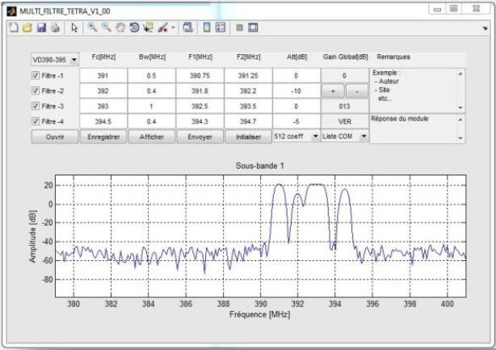

DAS features
Monitoring | LoRa over optical fiber
Monitoring frequency | 868MHz (option 433MHz)
Rus allowed | 16 (6xRus for 1xOMU 1U)
FO max. distance | 35KM
FO specs. | SC-APC/WDM1310-1550nm/Popt+3dBm
FO redundancy | Up to 2xFO per RU with the MDAS RU COUPLER

Monitoring features
Alarm | Minor/major alarms on native’s dry contact  Minor alarm says MOR ok Major alarm says MOR not ok
LED (native) | Minor (RED BLINK)  Major alarm (RED permanent)
I/O (native) | 2x dry contact / 2x optocoupled input
I/O (option) | 8x dry contact / 8x optocoupled input
PLC (option) | EWON FLEXY 202 (RFFO) / 205(RFRF)
Remote monitoring platform | Talk2M©
Cybersecurity | ISO 27001 / IEC62443  Level 1: Physical LAN commutation Level 2: Firewall  Level 3: Traffic encryption (OpenVPN/SSL/TLS) Level 4: Factory/user access policy  Level5: Server infrastructure monitoring  Level 6: Company policy compliance
Distant connection (option) | 3/4G/RJ45
Local protocol | OPC UA, Modbus, MQTT, SNMP, HTTP

Mechanical characteristics
RF ANT connector |  | N-Type (female)
Dimensions (H x P x l) |  | RFRF / FORF RU 580x150x400mm (BOX)  RFFO MU 133x450x483mm (3U 19”)  RFRF/ FORF RU 177x450x483mm (4U 19”)
Weight |  | RFRF / FORF RU 18.5kg (BOX)
Protection | Box | IP65
 | Rack | IP20
Cooling system | Box | Natural cooling convection  (Internal FAN are used to increase MTBF but not required for nominal operation)
 | Rack | Internal fans (redundant)
Temperature range |  | -25 / +50 °C
RAL |  | 9002
Relative humidity range |  | ≤95%
MTBF |  | 100 000h

Electrical characteristics
REPEATER (MU, RU, RFRF)
Power supply | 100-240VAC / +48VDC / +24VDC
Internal power converter |  | Redundant (option)
Power consumption | UL ↓ / DL → | +17dBm | +30dBm
 | +17dBm | 45W | 75W
OMU
Dimensions |  | 1U / 6xFO
Power supply / consumption |  | 100-240VAC / 50W
For more information: www.see-critical.com

